**Report – Pong Long**

**CO203 ASSIGNMENT 2**

*What the game is about?*

To start the game you will need to click the button on the menu page and automatically the game will being. The game is surrounded around the idea of Pong, however instead of two rectangles (paddles) it only consists of one long rectangle moving left to right with the help of the left and right keyboard keys(as interaction). There are two balls that will have to bounce of the rectangle in order for you to stay in the game. Each ball bouncing of the rectangle will give you a one point for your score. If one ball hits the bottom of the frame it is game over. To make the game a little more complex the gamer will be in for a shock as when they reach a total of 10 points one of the ball leaves the game and the remaining gets faster making it harder for you to catch the ball with the rectangle in order for you to stay in the game.

*How it is supposed to works.*

Shapes

Oval, Oval2, Rectangle extends Shapes and can all be held in collection.

My shapes class is abstract which contains the characteristics of the other shapes e.g. oval, oval2 (second ball) and rectangle. All these shapes create the environment. The individual classes draws the shapes and gives it values. To add, the rectangle class key handler class is detailed here.

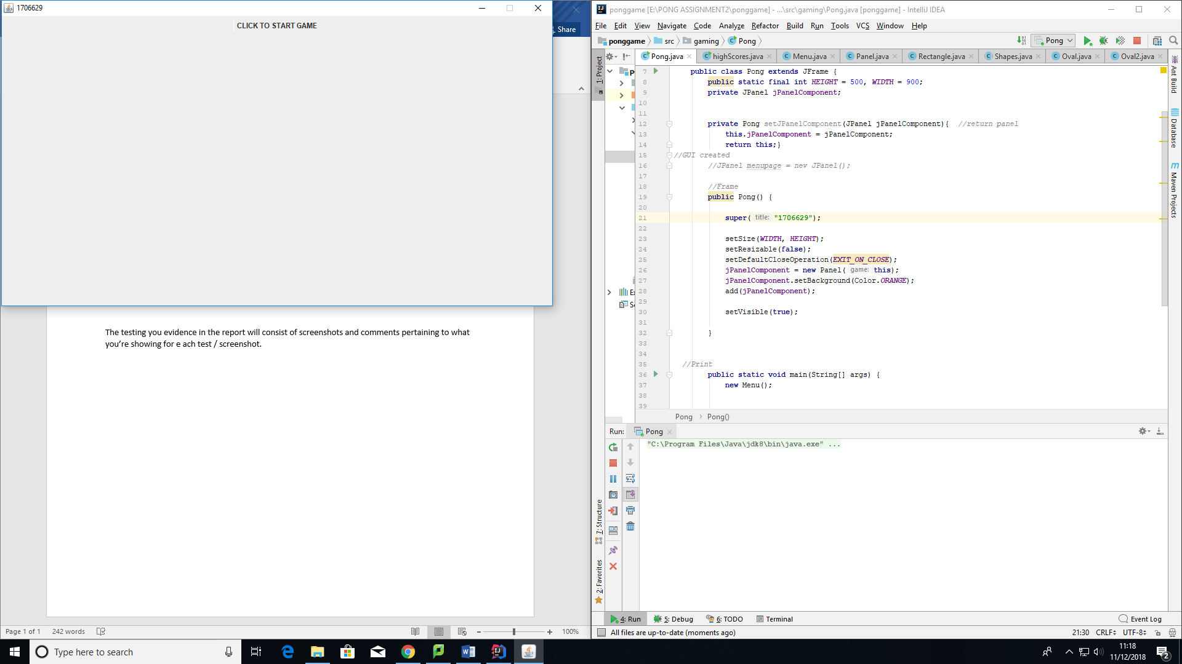Menu

The menu class contains a frame which contains a mouse listener. The game will begin as soon as the button has been clicked. My registration number is the title

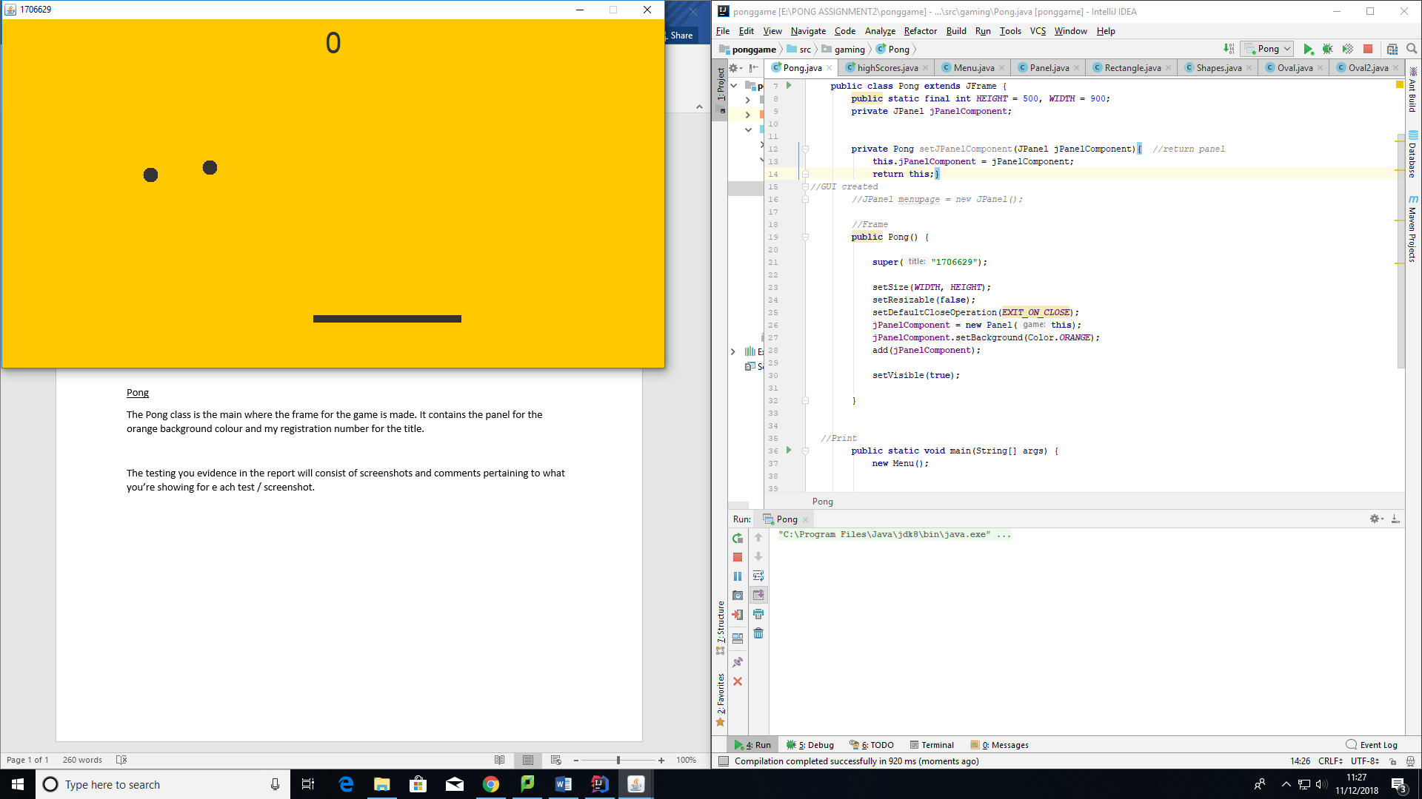Pong

The Pong class is the main where the frame for the game is made. It contains the panel for the orange background colour and my registration number for the title. The use of shapes to create the game environment is shown here.

Panel

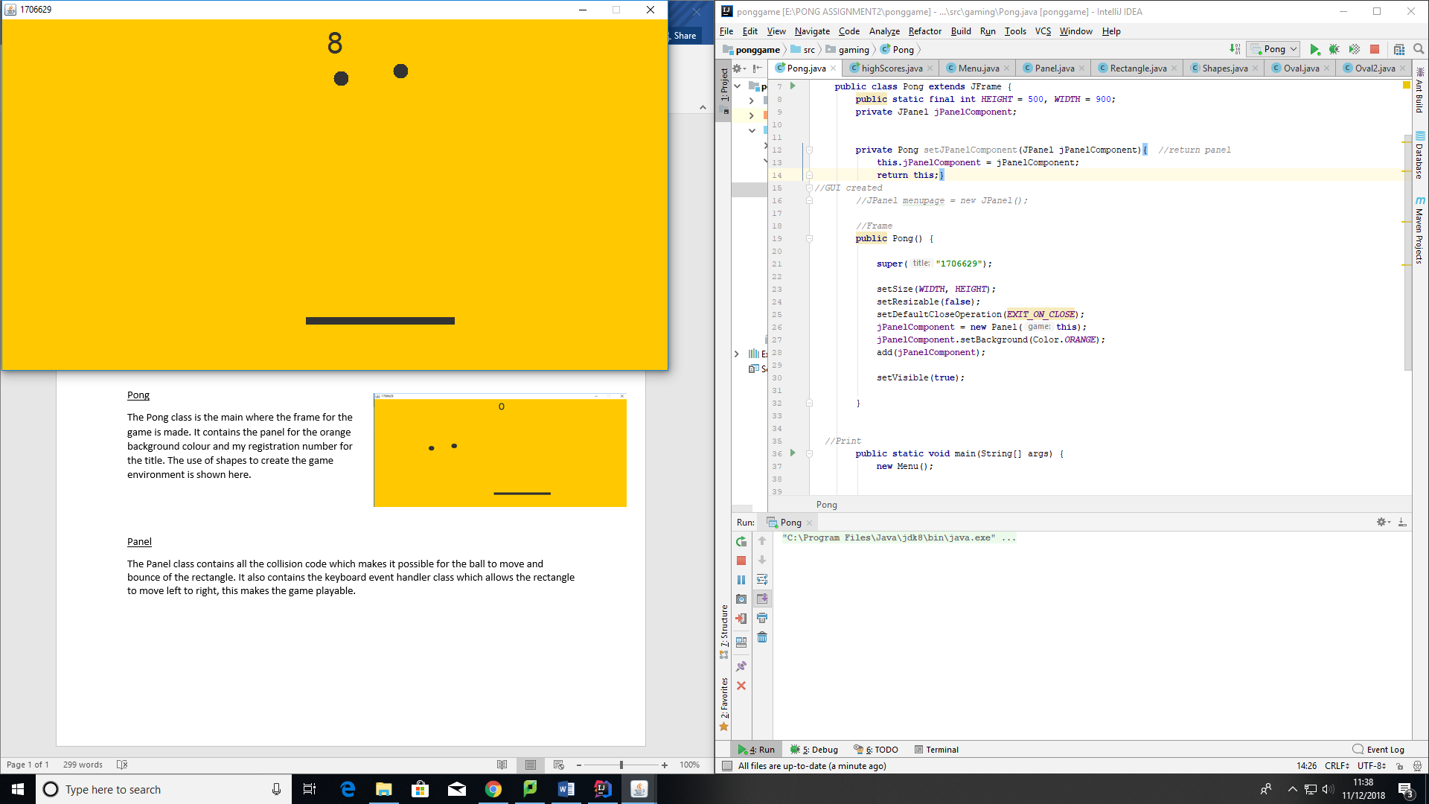The Panel class contains the game features (all the collision code, positioning, time delay etc.) which makes it possible for the ball to move and bounce of the rectangle. It also contains the keyboard event handler class which allows the rectangle to move left to right, this makes the game playable. You can also see how the score has increased due to the ball bouncing of the rectangle.

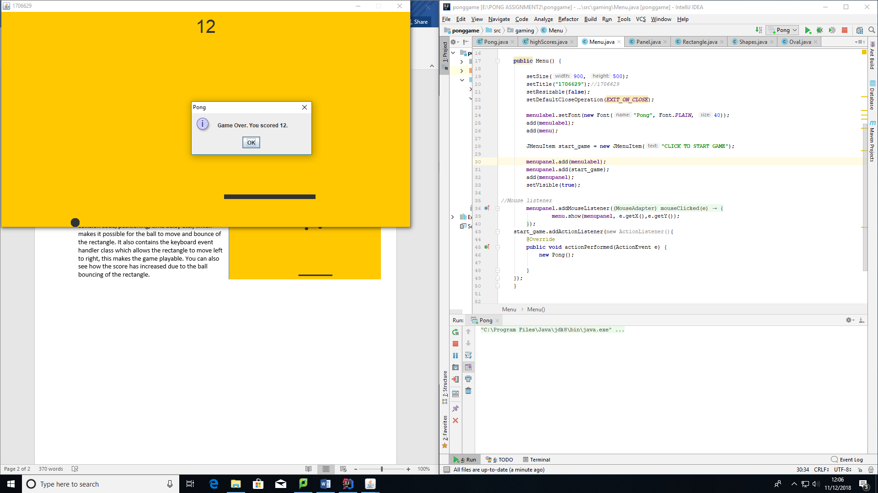

This screenshot shows what happens when the game becomes complex. It shows the score over 10 and one ball (the fast one) meeting the bottom of the frame which means game over. It also shows the score at the end of the game.

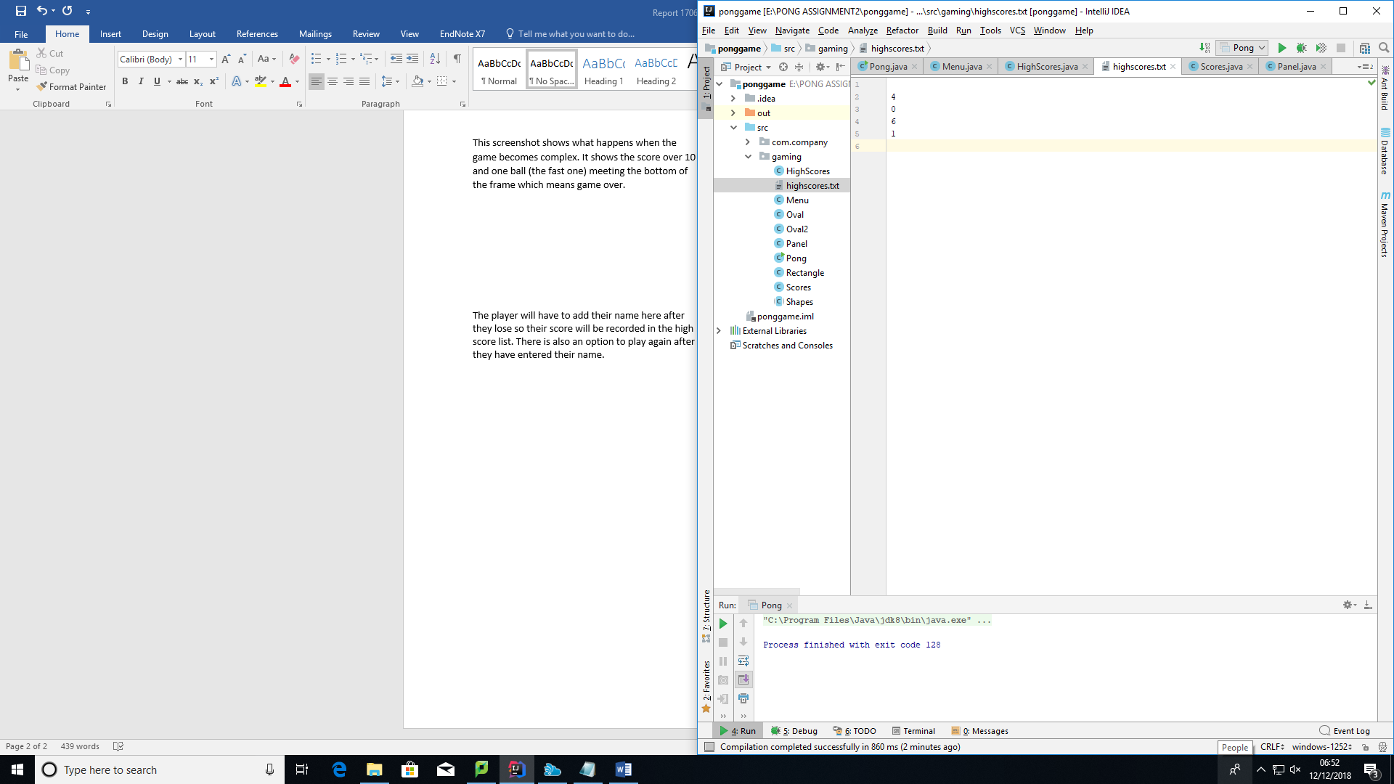

Once the player loses the score will be added to the text file.